Aim: To obtain the best fit line over single feature scattered datapoints using Linear Regression
IDE: Google Colab

Theory:

Linear regression is a method for determining the best linear relationship between two variables X and Y. If variables X and Y are uncorrelated, it is pointless embarking upon linear regression. However, if a reasonable degree of correlation exists between X and Y then linear regression may be a useful means to describe the relationship between the two variables. The usual approach is to use the least-squares method, which minimizes the squared difference between the actual data points and a straight line. Let [x_{i},y_{i}], i = 1,2,3,….,N be the N pairs of data values of the variables X and Y. The straight-line relating X and Y is y = mx + c, where m and c are the gradient and constant values (to be determined) defining the straight line. Thus, y(x_{i}) - y_{i} is the difference between the line and data point i (see Fig. 1). Taking all the data points, we seek values of m and c that minimize the squared difference SD.
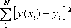

This is achieved by calculating the partial derivatives of SD with respect to m and c and finding the pair [m,c] such that SD is at a minimum.
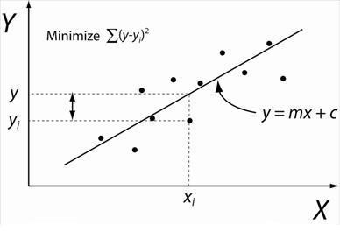

Figure 1: Illustration of Linear Regression. Linear least squares regression, the idea is to find the line y = mx + c that minimizes the mean squared difference between the line and the data points

Batch Gradient Descent:
Gradient Descent is an optimization algorithm used for minimizing the cost function in various machine learning algorithms. It is basically used for updating the parameters of the learning model. Batch gradient descent which processes all the training examples for each iteration of gradient descent. But if the number of training examples is large, then batch gradient descent is computationally very expensive.
Let m be the number of training examples. Let n be the number of features.

Algorithm for batch gradient descent :
Let h_{θ}(x) be the hypothesis for linear regression. Then, the cost function is given by:
Let Σ represents the sum of all training examples from i=1 to m.
J_{train}(θ) = (1/2m) Σ( h_{θ}(x^{(i)}) - y^{(i)})²
Repeat {
θj = θj – (learning rate/m) * Σ( h_{θ}(x^{(i)}) - y^{(i)})x_{j}^{(i)}
For every j =0 …n
}
Where x_{j}^{(i)} Represents the j^{th} feature of the i^{th} training example. So if m is very large(e.g. 5 million training samples), then it takes hours or even days to converge to the global minimum.That’s why for large datasets, it is not recommended to use batch gradient descent as it slows down the learning.

Pre Lab Exercise:
- Explain the meaning of linear regression
Linear Regression is a supervised machine learning algorithm used to model the relationship between a dependent variable (Y) and one or more independent variables (X). It finds the best-fit straight line (y = mx + c) that minimizes the difference between predicted and actual values using the least squares method.
- Write three applications of linear regression
- House Price Prediction – Predicting prices based on area, location, etc.
- Sales Forecasting – Estimating future sales using past data
- Student Performance Prediction – Predicting marks based on study hours

- Write three advantages of linear regression
- Simple and easy to implement
- Computationally efficient
- Interpretable results
- Write three limitations of linear regression
- Assumes linear relationship
- Sensitive to outliers
- Requires assumptions like normality and independence

Methodology:
- Load the basic libraries and packages
- Load the dataset
- Analyse the dataset
- Pre-process the data
- Visualize the Data
- Separate the feature and prediction value columns
- Write the Hypothesis Function
- Write the Cost Function
- Write the Gradient Descent optimization algorithm
- Apply the training over the dataset to minimize the loss
- Find the best fit line to the given dataset
- Observe the cost function vs iterations learning curve

Program (Code):

import numpy as np
import pandas as pd
import matplotlib.pyplot as plt

url = "https://raw.githubusercontent.com/mwaskom/seaborn-data/master/tips.csv"
df = pd.read_csv(url)
print("Dataset Preview:\n", df.head())

X = df['total_bill'].values
Y = df['tip'].values
m = len(X)

plt.scatter(X, Y)
plt.xlabel("Total Bill")
plt.ylabel("Tip")
plt.title("Scatter Plot (Before Training)")
plt.show()

theta0 = 0
theta1 = 0
learning_rate = 0.0001
iterations = 100
def hypothesis(x, theta0, theta1):
return theta0 + theta1 * x
def compute_cost(X, Y, theta0, theta1):
total_error = 0
for i in range(m):
total_error += (hypothesis(X[i], theta0, theta1) - Y[i]) ** 2
return total_error / (2 * m)

cost_history = []

for i in range(iterations):
sum_theta0 = 0
sum_theta1 = 0
for j in range(m):
error = hypothesis(X[j], theta0, theta1) - Y[j]
sum_theta0 += error
sum_theta1 += error * X[j]
theta0 -= (learning_rate / m) * sum_theta0
theta1 -= (learning_rate / m) * sum_theta1
cost = compute_cost(X, Y, theta0, theta1)
cost_history.append(cost)
if i % 100 == 0:
print(f"Iteration {i}: Cost = {cost}")

print("\nFinal Intercept (theta0):", theta0)
print("Final Slope (theta1):", theta1)
predicted_Y = hypothesis(X, theta0, theta1)
plt.scatter(X, Y, label="Actual Data")
plt.plot(X, predicted_Y, color='red', label="Best Fit Line")
plt.xlabel("Total Bill")
plt.ylabel("Tip")
plt.title("Best Fit Line after Training")
plt.legend()
plt.show()

plt.plot(range(iterations), cost_history)
plt.xlabel("Iterations")
plt.ylabel("Cost")
plt.title("Cost Function vs Iterations")
plt.show()

test_value = 50
predicted_tip = hypothesis(test_value, theta0, theta1)
print(f"\nPredicted Tip for Bill = {test_value} is: {predicted_tip}")

Results:
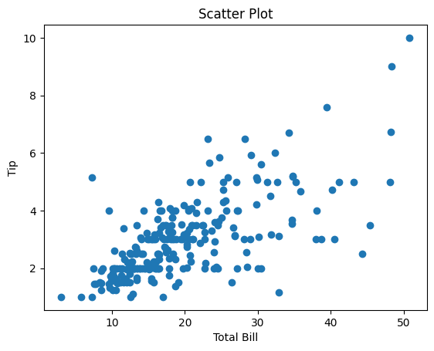
- Datapoints scattering (without best fit line)
- Scatter plot showing the Best fit line in the last iteration of training
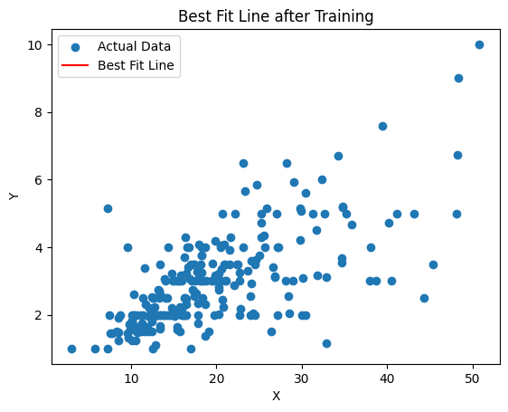

Observation and Result Analysis:
- Nature of the data
- The dataset used is the Tips dataset
- It contains single feature input and target output
- The scatter plot shows a positive linear relationship between total bill and tip
- Data contains real-world noise and variation, as tipping behavior is not perfectly linear
- During Training Process
  - The cost function (MSE) decreases gradually with each iteration
  - Parameters are updated using all training examples in each iteration
  - Learning rate used is 0.0001 (small) to ensure stable convergence
- After the training Process
- A best-fit line is obtained that represents the relationship between bill and tip
- The cost reaches minimum value
- The model can now predict tip values for new bill amounts
- The regression line closely follows the trend of the data points

Post Lab Exercise:
- What are the major assumptions considered in linear regression
- Linearity – Tip increases linearly with total bill
- Independence – Each customer’s bill is independent
- Homoscedasticity – Variance of errors remains constant
- Normality – Errors follow normal distribution
- No multicollinearity – Only one feature is used
- Why MSE is used instead of MAE for calculating the loss function
- MSE penalizes large errors more, which improves accuracy
- It is differentiable, making it suitable for gradient descent
- Provides a smooth cost curve, helping stable convergence
- How can the behaviour of outliers be understood while dealing with the unseen dataset
  - Outliers can distort the regression line
  - MSE gives more weight to large errors → outliers strongly affect model
  - In this dataset, some variation exists due to human behavior

- Derive the Normal Equation for the Linear Regression.

$θ=\left(X^{T}X\right)-1X^{T}y$

